Wayne State University
Peer Mentor Handbook





August, 2011
Table of Contents

What are Learning Communities .......................................................................................3
Vision
Background
Our Program
Peer Mentor Component
Skills of Effective Mentors ..................................................................................................6
Keys to Success
Standards of Behavior for Peer Mentors…..........................................................................8
Confidentiality
Integrity
Ethical Standards
Issues and Challenges for Peer Mentors..............................................................................10
Issues for Students
Challenges You May Encounter as Peer Mentors
Nuts and Bolts of Being a Peer Mentor................................................................................12
What to Expect from Supervisors
Tracking Student Information
Ice-breakers/Energizers, Teambuilders, and Conversation Starters
Establishing Effective Study Groups
Programming/Activities

Appendix………………………………………………………………………………………………………………………….18
Resource List of Offices/Services

Additional materials available for download at
http://www.lc.wayne.edu

Acknowledgement

Much of the content in this Handbook was taken from the peer mentor handbook developed by Kurt Earnest, Doug Gruenewald, and Mimi Benjamin at Iowa State University. We thank them for allowing us to use their excellent materials.

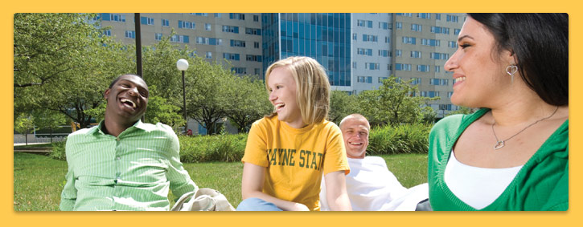

What are Learning Communities

Vision
To support Wayne State University’s commitment to student learning, the Learning Community initiative seeks to enhance our undergraduates’ experience by providing all interested students dynamic, focused communities in which students, staff, and faculty can learn and grow together.

“Such communities can be organized along curricular lines, common career interests, avocational interests, residential living areas, and so on. These can be used to build a sense of group identity, cohesiveness, and uniqueness; to encourage community and the integration of diverse curricular and co-curricular experiences; and to counteract the isolation that many students feel.”
Astin, A. W., Achieving Educational Excellence
San Francisco: Josey-Bass, p. 161, 1985
Background
Wayne State is part of a national movement in higher education to develop learning communities as a means to enhance student learning and success. The initiative was structured to incorporate principles that have been shown to be most effective (Shapiro, N. and Levine, J., Creating Learning Communities, San Francisco: Josey-Bass, p. 3, 1999):
- Organizing students and faculty into smaller groups
- Encouraging integration of curriculum
- Helping students establish academic and social support networks
- Providing a setting for students to be socialized to the expectations of college
- Bringing faculty together in more meaningful ways
- Focusing faculty and students on learning outcomes
- Providing a setting for community-based delivery of academic support programs
- Offering a critical lens for examining the first-year experience

Further, according to Shapiro and Levine (p. 3), learning community models can be varied to meet specific needs and interests of students and faculty:
- Curricular Structure: How courses and students are organized to form communities
- Faculty Role: The levels of faculty development and ways that faculty collaborate to achieve curricular integration
- Curricular Opportunities: The ways that learning communities approach integrating students’ in-class and out-of-class experiences
- Opportunities for Peer Leadership: Leadership roles in learning communities for community members or upper-division students

Our Program
The current Learning Communities program began in 2004 with the advent of Living Learning Communities (LLC’s) in the newly-constructed residence halls. The program was a collaborative initiative of the Honors Program, the Office of Housing and Residential Life, the Dean of Students Office, and the schools and colleges. The idea was that students with similar academic and co-curricular interest live in the residence halls and join thematic and academic communities that promote a heightened sense of commonality and encourage collaborative learning. LLCs were not limited to residential students - commuter students were also encouraged to participate.

In Fall 2006, the notion of learning communities was broadened to include any academic program interested in using learning communities to enhance student learning and success, whether residential or not. Further, the focus could be on first-year students or upper class students. The chart below shows the growth of learning communities and the increase in student participation as a result of the Learning Communities initiatives started in 2006. For 2010-2011, forty-four (44) different learning communities have been formed, and currently 2364 students participate.

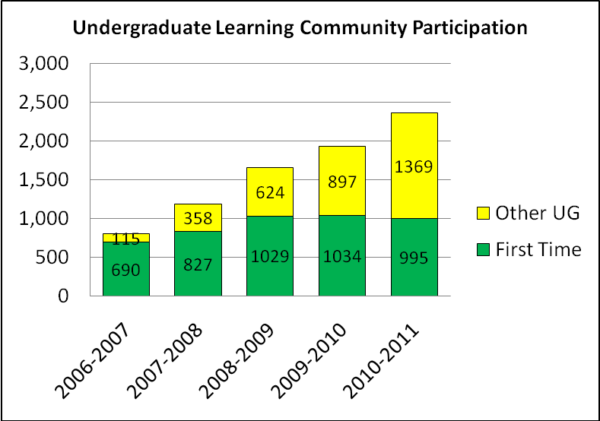

The university takes a broad view of what constitutes a learning community, but all programs denoted as learning communities must address the following based on best practice:
- having clearly delineated academic and social goals.
- involving faculty and academic staff.
- having the support of the responsible administrative unit(s), including financial support in terms of staffing and direct cost-sharing of the programming budget.
- having a well thought-out plan to assess the achievement of both the academic and social goals.

Peer Mentor Component
Beginning in Fall 2006, Peer Mentoring became an integrated part of the program. Peer Mentors facilitate student learning in their programs, and special training sessions are held for them before the academic year begins and during the year. Research shows that peers play a crucial role in student success. As a result of introducing Peer Mentoring, student success rates among learning community participants has increased continually based on student retention (staying in school) and student achievement (grades, credits earned, etc.).

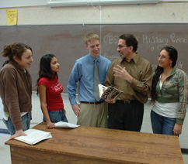
Skills of Effective Mentors
Peer Mentors are THE KEY to a Learning Community's success! You are the liaison between the students in your Learning Community and the faculty and staff who run the Learning Community. You provide support, guidance and connection for all of your Learning Community students. The Learning Community coordinators look to you for feedback and will work with you to make your Learning Community the best it can be.
Mentors must develop a variety of skills in order to perform and serve their students effectively. In most cases you will deal with issues related to academics, but as your relationship grows with your students, they may come to you with issues of a more personal nature – these issues will often have an impact on their success as a student. The most important thing to remember in any situation is that you’re not a counselor. Know your limits – sometimes the best way you can help others is by referring them to someone else with more experience.

Keys to Success
• Listening
• Asking open-ended questions
• Attending and responding to both content and feeling
• Letting the student solve the problem
• Referring to/using your resources

Listening – fully participate in a conversation by being an active listener and utilizing some simple counseling skills such as reflecting, encouraging and asking questions. Be aware of how your body language can affect communication.

Asking open-ended questions - Any question that elicits a “yes/no” answer won’t be as helpful as a “what, when, how, who” question. “Why” questions may seem like they would get more information, but keep in mind that they can sometimes imply criticism and cause defensiveness (i.e., “Well, why didn’t you go to all the study sessions?”). It is better to ask “What benefits do you see in attending all the study sessions?”

Attending and responding to both content and feeling - Often there are two things going on at once – there is an issue, and the person has some kind of feeling or reaction to that issue. You need to attend and respond to both. Consider this: “I’m so mad about my Chem test!” What is the content (performance on the Chem test)? What is the feeling (anger)? It’s important to attend to both. You might say “I can tell that you are angry about your performance on the chemistry test. I remember my own feelings when I had a test that seemed unfair. Let’s talk about how you can approach your next test.” Remember that issues presented to you could have some underlying themes and might even be symptoms of a larger problem.

Letting the student solve the problem - It’s easy to want to try to solve things for people, but that’s not as helpful as it might seem. Usually, the student knows the answer or knows how to solve the problem but just needs someone to ask the right questions and encourage the right processing. By facilitating your students to solve their own problems, you are actually giving them skills they can use in future situations. Often, the best answer is to ask the right question.

Referring to/using your resources - You are not a trained counselor. Don’t expect yourself to be. But know your resources (your Learning Community Coordinator, Dean of Students Office, etc.) and help people make use of those individuals and services. It’s OK to say, “I don’t know” as long as you get the information for the person. If you feel a student needs to be referred for additional help or counseling, let your supervisor know immediately.

A NOTE ABOUT Self-disclosure – Try not to reinforce student stereotypes or negative perceptions. If you say things like “I was in that situation, too, and it sucked and no one helped me and blah, blah, blah,” you aren’t providing viable problem-solving alternatives. Instead, say something like “I was in a similar situation and I did this which helped.” This sort of self-disclosure is honest and helps your students to take responsibility for their own success.

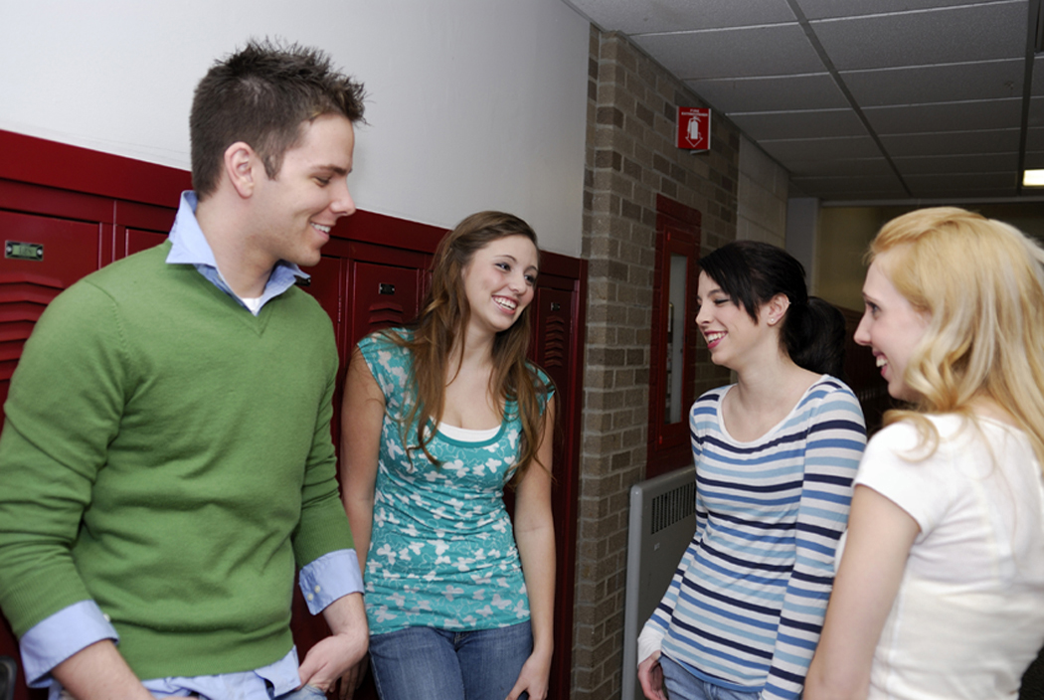

Standards of Behavior for Peer Mentors
As a Peer Mentor, you have big responsibilities. You must always stay professional and be a positive role model in terms of integrity and ethical behavior. You also must maintain appropriate boundaries with your mentees. You are not their friend, you are their Peer Mentor. Your relationship is always professional. That requires also keeping information you learn about individual students confidential.

Confidentiality

The mentor-mentee relationship is based on developing an open and caring relationship based on trust. As a Peer Mentor you will be working with students who are often new to the idea of opening up to anyone. The importance of confidentiality and maintenance of trust is the basis for the development of the relationship.

Information shared between a mentor and student cannot always be confidential. In some specific instances, maintaining that bond of trust means that you need to share information with others. If a student discusses with you a situation that could result in self-harm or harm to others, it is your responsibility to report that information immediately to the appropriate persons (Learning Community Coordinator, Advisor, etc.). If the student has a condition that is beyond your ability to assist with (serious neurosis, alcohol, drug problems or depression), it is in the student’s best interest that you share that information as well.

The primary people with whom you should share specific information about an individual student are the staff and faculty who supervise your learning community. They should be the first one’s you go to. If there is the need for further intervention, and your supervisor passes the information along to relevant professional staff, you may be asked to discuss the situation. That is appropriate as long as it is done in a professional manner.

If you are contacted by a student’s parents or guardians, refer them to your supervisor. There are strict guidelines that govern the sharing of student information, and your supervisors are trained to follow the laws for disclosure.

When you are “off duty,” do not discuss confidential information for your mentees with your family, significant others, friends, or roommates. They do not have a right to know, and you do not have a right to disclose confidential information to them.

Integrity

Integrity is the foundation for a solid and productive relationship with the mentees and with the respective Learning Community staff. A Peer Mentor must display a consistent and positive self-concept including strong values and a respect for the policies and procedures of the Learning Community.

A Peer Mentor must:
Be vigilant of his/her role as a representative of the Learning Community
Be vigilant of his/her role as a representative of Wayne State University
Exhibit a level of professionalism while still maintaining a peer relationship with mentee

Standards of integrity extend to the developing relationship with the students and to the Learning Community staff, and to the manner by which the mentor relates and reports to the staff.

It is imperative that:
Any documentation of hours worked and time spent participating in Learning Community activities must be reported accurately and in the best interest of the mentee and the university.
Student mentors track their own time and report it as required.
Mentors understand the importance of following the guidelines and maintain the standards that the Learning Community seeks in its mentors.

Ethical Standards

As you perform your duties as a Peer Mentor, it is critical to understand and practice ethical behaviors. You were selected for this position because you possess the ability to establish strong rapport with students. The interpersonal skills that made you a prime candidate for the position can also place you in challenging situations. As you serve in your role, it is important to adhere to some guiding principles of the helping profession.

(Excerpted from Student Helping Students, Ender, S. and Newton, F., 2000, Jossey-Bass Publishers)
• Peer Mentors will have knowledge and act consistently with the standards that are appropriate to the agency in which they are employed.
• Peer Mentors will avoid acting beyond the scope of the service for which they were selected and trained and not attempt to offer professional services requiring more extensive qualifications and training.
• Consult with your supervisor when you face a situation that makes you uncomfortable or when you experience a conflict or dilemma.
• Act appropriately when working with persons for whom you feel attraction. Establishing intimate or strongly personal relationships with your mentees is not appropriate and compromises your helping role.
• Remember that as a mentor you are a role model. You are obligated to maintain congruence between what you say to fellow students in your role and how you act in other facets of your life where you can be seen (or heard).
• Avoid over-familiarity with mentees by maintaining a degree of professional distance.


Issues and Challenges for Peer Mentors

Students in Wayne State University Learning Communities range from incoming freshmen to PhD students. The challenges they face evolve as students progress through different stages of their educational experience. Even so, many of the issues students face in adapting to new learning situations, developing their skills as learners, relating to others in the educational setting, and the like, have common aspects.

Peer Mentors play a crucial role in student success, and that comes with a number of challenges as well. Many students need to adjust to college expectations, develop study skills, and become more motivated as learners. That makes the Peer Mentor job even harder.

Issues for Students

When assisting students with these issues, be sure that you utilize the resources available to you. Sometimes the most important pieces of information you can provide are the names/ locations of others who are trained to assist students with these concerns.

Talk with your Learning Community Coordinator about addressing issues such as these as well as other concerns you may encounter.

Intellectual/Academic challenges
• Speaking up in class
• Communicating with professors
• Developing semester course schedules
• Seeking academic assistance when problems arise
• Balancing academics and social life

Interpersonal challenges
• Connecting with a new friendship group
• Learning how to show emotions in appropriate ways
• Managing conflict situations
- Learning to contribute effectively in groups

Career/ challenges
• Choosing or changing a major or minor
- Deciding on participation in internships, service learning, undergraduate research, or other similar opportunities

Personal challenges
• Moving to a new environment
• Leaving family
• Living with a roommate
• Meeting new people
• Making personal decisions everyday
• Facing new peer pressures (sex, drugs, alcohol, etc.)
- Dealing with personal relationships

Transfer Students
Some of you will have the opportunity to work with transfer students. While transfer students are “new” to the university, they are not “new” to college. However, they may have some similar issues as first-years in terms of transitioning to a new environment. Such issues as becoming familiar with Ames and the Iowa State University campus as well as adjusting to large classes may be challenges they face. In addition, many of their peers already have established their “friend groups.” Finding where they fit may be something you’ll discuss with them.

Challenges You May Encounter as a Mentor
There is no “standard” method to use to address the challenges you may encounter. Be sure to talk with your supervisor about challenges that you’re facing in your Peer Mentor role. Other Peer Mentors may also be helpful to you as you address different issues. There are many resources available to assist you. Be sure to use them!

Motivating/encouraging
• Getting students excited about school/activities
• Students not wanting to participate in planned activities
• Trying to make everyone happy
• Dealing with apathy
• Students not meeting expectations
Role perceptions
• Not being viewed as a peer
• Students wanting you to solve their problems
• Not being seen as an authority figure
Personal issues
• Giving advice without personal morals/values getting in the way
• Dealing with roommate issues
• Confrontation/assertiveness issues
• Programming/activities
• Breaking the ice
• Being inclusive
• Getting everyone involved
Addressing questions
• Helping others understand their major
• Not being able to answer certain questions
• Not giving too much advice but empowering the student
• Reaching out to those who need assistance but won’t ask for it
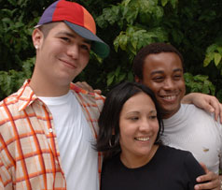
Nuts and Bolts of Being a Peer Mentor

What to Expect from Supervisors

Working with your supervisor will be key to your success as a Peer Mentor. Your supervisor will provide you with information about the program as well as expectations for your role.
Listed below are some topics to be sure to discuss with your supervisor at the beginning of the semester. Some topics will be revisited regularly during your time as a mentor.
Program Goals/Outcomes
• What does your supervisor want you to accomplish in your role? (Short Term, Semester, Year)
• What should students gain from their participation in the program?
• How will your mentor responsibilities help students accomplish the program goals?
Expectations
• Do you have a copy of the job description?
• What are your supervisor’s expectations of you?
• What are your expectations of your supervisor? What do you need from your supervisor in order to be effective?
• How will you know that you’re being successful in your role? How and when will your supervisor provide you with feedback?
Providing Information
• Does your supervisor want you to keep track of the interactions you have with students?
If so, how?
• Is there a form your supervisor would like you to use to report information?
Meetings
• What is the intent of the meetings?
• What information should you be prepared to share at the meetings?
• When and where will you regularly meet?
• If there is more than one mentor for the program, should mentors plan to meet outside of regularly scheduled group meetings with the supervisor?
Resources
• What resources does your supervisor have that you may need access to (this may include a budget, professionals in the field/contacts, etc.)?
The most important thing to do is talk with your supervisor about what you need and what you should expect from him/her so that you can be most successful as a Peer Mentor.

Tracking Student Information

It is very important to keep records of the interactions you have with your mentees. You will need to keep careful notes, including

- Who attended sessions and events?
- What issues do individual students face that need attention of your supervisor?
- What general issues are you identifying that might need to be addressed?
- What ideas do you have to improve student learning and how your learning community is meeting its student learning outcome goals?

An easy way of remembering your interactions with your students is by writing them down. You don’t need to record every interaction, as some interactions will be social, but when students come to you to discuss problems they’re dealing with or something pertaining to your mentor role/relationship with them, it’s a good idea to keep a record. There are many ways that this can be done; ask your supervisor about his/her expectations of tracking information or feel free to do whatever works best for you.

It is important to remember that, whichever way you choose to record interactions with your students, it must be kept confidential and put away so that only you have access to it. Check with your supervisor about what information he/she wants you to track.

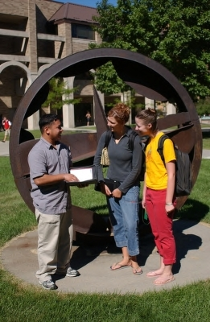
Ice-breakers/Energizers, Teambuilders, and Conversation
Starters

Ice-breakers/energizers and teambuilders are a great way to start off any meeting in order to set the tone for the duration of the gathering. They allow participants to feel integrated within a group, break up already formed groups/cliques, and unify all individuals by participating in an activity that has a shared goal for the entire group.

Conversation starter ideas
As a mentor, you should be in constant communication with the students with whom you are working. Many times you will have specifi c reasons to approach them in conversation. Other times, you may need a “starter”, especially if the student is shy and not likely to approach you.

The following are some ideas to use to start up conversations with students in your community:
• The most basic…introduce yourself as the Peer Mentor and let the student know what your role is and how you’ll be available to them throughout the year.
• Ask about the classes they are taking, how they’re going, etc. If you have a similar major, ask about their instructors – maybe you’ve had some of the same ones.
• See if they’ve gotten involved in any groups on campus. Learn about their interests so you can continue to ask them questions or pass on information related to the subjects they like.
• Take information you’ve heard from others (maybe about where a person is from or activities they enjoy) and talk to them about it – “I heard that you played basketball in high school. Have you heard about ISU’s intramural program?” or “Someone told me you were from Chicago. I am too – what area are you from?”

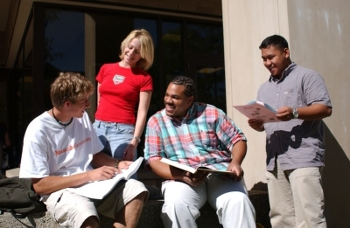

Establishing Effective Study Groups

A large part of your job as a mentor is to maintain an environment that encourages academic success. The students involved in your learning community are in a wonderful situation where they can take advantage of the common academic goals of their peers. A great way to encourage the daily integration of academics into the lives of your students is by encouraging them to study together on a regular basis. The following is just a short list of the positive effects of study groups.
Study groups…
• Provide an opportunity where peers can teach each other by reinforcing and clarifying learning.
• Make learning more interesting and fun by providing a type of support group.
• Help students feel more comfortable with material so they can discuss it in the classroom environment.
• Motivate students to study because the success of the group depends on the participation of all members.
Things you can do as a mentor to help establish study groups:
• Create sign-up sheets that go along with the classes you know your students are taking.
• Provide tips on how to study effectively – staying on subject, having an agenda, setting a start and stop time, etc. Check out the Academic Success Center for more ideas.
• Work with your resources to set study hours in a quiet location.

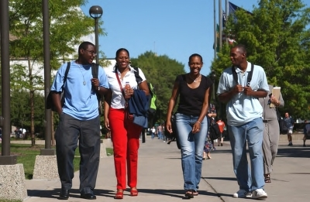

Programming/Activities

Identifying program activities/getting feedback
A good way to find out how things are going in your community is to ASK the people who are participating in it. This can be done a number of ways.
Brainstorming- ask students about their goals for the year and what kinds of activities they would like to see made available – both social and educational. Write down the ideas they give you! When you’re looking for something to plan, go to that list. People like knowing that their comments matter.
Survey/Assess- after an event, hand out a short survey asking what the participants thought about it – if the content was good, what they learned, what could’ve been done better, what was done really well, etc. You can also ask for verbal responses. Be sure to take these comments into consideration for future planning. Again, don’t forget to use your resources (like your Learning Community Coordinator) to help you assess and evaluate your new data.
Talk with other mentors: get together with other mentors and see what programs/activities they have tried, what has worked and what hasn’t. Remember to take into consideration your learning community differences that might affect the outcome of a particular program.

Program planning checklist
As a mentor, there will be times when you will need to plan programs and activities for your learning community. These may be social or educational/academic in nature. Ideas include:

Educational/academic
• Bringing in speakers
• Organizing study groups
• Taking tours of companies related to the Learning Community major/theme
• Attending lectures on campus
• Portfolio and resume workshops
• Campus group presentations: Fitness Center, Writing Center, Academic Success Center, etc.
• Community service opportunities

Social
• Going out to dinner or for dessert
• Pizza parties
• Bowling
• Watching movies
• Birthday parties
• Intramural teams
• Warrior athletics

Some things to take into consideration when planning include:
• What type of program/activity do I want to offer (social, educational, etc.)?
• Where will this program be/what facilities are available?
• What resources do I need to carry out this program? Do I need specific equipment and where can I obtain it if needed?
• What dates are possibilities for this program – how can I maximize attendance and avoid conflicts?
• Are there any costs involved in this program? Will I need monetary support?
• Do I need approval for this program?
• Does this program comply with university policies regulating activities?

Reserving meeting space on campus

At different times during the year you might find it useful to reserve meeting or activity space on campus.
Reserve a room by Phone: Call Dean of Student Office (DOSO) at (313)577-1010

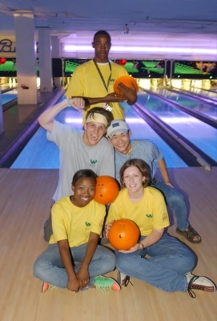

Appendix

